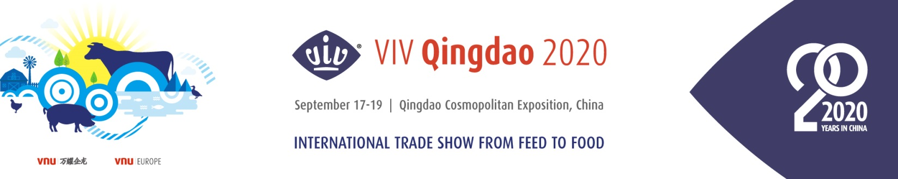
VIV Qingdao Hosted Buyers Program 2020
Dear Buyer,

VIV Qingdao 2020 invites you to apply for the hosted buyer program reserved to top buyers in one of the following sectors: large-scale farm, feed mill, meat slaughtering, food processing or distribution. To qualify, the Hosted Buyer MUST attend 2 days of the show AND
hold a minimum of 8 verified meetings.

- Basic Information (You can apply your business card directly. Maximum 1 person OR 1 room per company)*
Full Name |  | Country
Company Name |  | Job Title
Company Web |  | Phone Number
E-mail Address |  | Arrive Date

- Questionnaire*
- Are you interested in :
☐ Feed and feed ingredients
☐ Feed additives
☐ Feed milling equipment
☐ Bio-products (Vaccine, Veterinary drugs, etc.)
☐ Veterinary equipment/ Protective equipment
☐ Breeding/Hatching
☐ Farm and housing equipment
☐ (Meat/ Egg) Slaughtering/Processing/ Handling
☐ Logistics/ Refrigeration/ Packaging
☐ Premium livestock products
☐ Laboratory/Testing equipment and services
☐ IT & Automation services
☐ Waste Treatment equipment & Bio-energy Technology
☐ Aquaculture Farming Technology & Equipment
☐ Ruminant Farming Technology & Equipment
☐ Others:
- What is your 2020 purchasing budget for the above selected categories?
☐ Less than Euro 500.000 ☐ USD 500,000 – 5 million ☐ USD 5 million - 10 million ☐ USD 10 million - 25 million ☐ More than 25 million
- Do you plan on placing purchase orders at VIV Qingdao 2020?
☐ Yes _____________ ☐ No
- How many people work in your company?
☐ 1-50 ☐ 51-200 ☐ 201 - 500 ☐ More than 501
- How long have you been in the related industry?
☐ 1-3 ☐ 4-10 ☐ 11 - 25 ☐ More than 26

Note* Incomplete or unclear forms, will not be considered. Thanks for your cooperation.
☐ I agree to include my profile on the VIV Qingdao online business matchmaking free service.
___________________________________________________________________
To apply, please send the completed form to:

Contact person:
Ms.Kandy Tang kandy.tang@vnuexhibitions.com.cn
Service Center + (86) 400 821 3388 viv@vnuexhibitions.com.cn
__________________________________________________________________
NB: The organizers reserve the right to select the 400 buyers that will be hosted in this 2020 edition of VIV Qingdao.
www.VIVworldwide.cn WWW.VIVCHINA.NL

