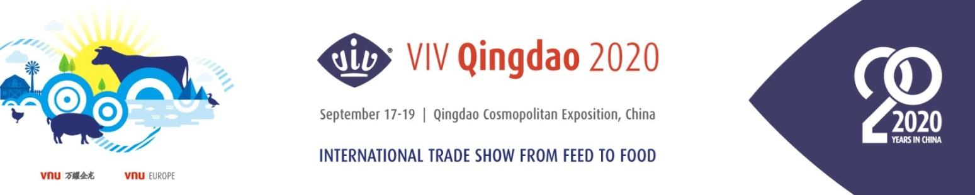
Online Match-making Hosted Buyers Program
Dear Buyer,
VIV Qingdao 2020 invites you to apply for the online match-making hosted buyer program reserved to top buyers in one of the following sectors: large-scale farm, feed mill, meat slaughtering, food processing or distribution. To qualify, the Online Match-making Hosted Buyer MUST attend 5 verified match-making meeting online during the exhibition period.

1. Basic Information*
(You can apply your business card directly.)*is required.
Full Name |  | Country
Company Name |  | Job Title
Company Web |  | E-mail
Estimated Online Match Making Date |  | ☐ September 17th, 2020 AM ☐ September 17th, 2020 PM  ☐ September 18th, 2020 AM  ☐ September 18th, 2020 PM  ☐ September 19th, 2020 AM

2. Questionnaire* (*is required)
- Are you interested in :
☐ Feed and feed ingredients
☐ Feed additives
☐ Feed milling equipment
☐ Bio-products (Vaccine, Veterinary drugs etc.)
☐ Veterinary equipment/ Protective equipment
☐ Breeding/Hatching
☐ Farm and housing equipment
☐ Slaughtering/ (Meat/ Egg) Processing/ Handling
☐ Logistics/ Refrigeration/ Packaging
☐ Premium livestock products
☐ Laboratory/Testing equipment and services
☐ IT & Automation services
☐ Waste Treatment equipment & Bio-energy Technology
☐ Aquaculture Farming Technology & Equipment
☐ Ruminant Farming Technology & Equipment
☐ Others:

- What is your 2020 purchasing budget for the above selected categories?
☐ Less than Euro 500.000 ☐ USD 500,000 – 5 million ☐ USD 5 million - 10 million ☐ USD 10 million - 25 million ☐ More than 25 million

- Do you plan on placing purchase orders at VIV Qingdao 2020?
☐ Yes _____________ ☐ No

- How many people work in your company?
☐ 1-50 ☐ 51-200 ☐ 201 - 500 ☐ More than 501

- How long have you been in the related industry?
☐ 1-3 ☐ 4-10 ☐ 11 - 25 ☐ More than 26

3. How to Apply

- Click HERE to complete VIV Qingdao 2020 pre-registration.
- Directly login VIV Qingdao 2020 ONLINE MATACH-MAKING system from confirmation page of pre-registration.
- View the company product information on Match-Making system and choose at least 8 exhibiting companies that you have interest to talk with and put these 8 companies together in the below form.
No.1
No.2
No.3
No.4
No.5
No.6
No.7
No.8

- The organizer will verify your profile and check the intention with the selected exhibiting companies to confirm a final online match-making agenda with you.
- The buyer should complete online match-making agenda as scheduled to get the prize.

4. Benefits
- The buyer will be awarded an amazon gift card valued at $100 if he/she could complete at least 5 verified match-making meeting online during the exhibition period.
(The buyer should first send application for hosted buyer to the organizer by email before 14th August. Once the profile verified, the organizer will help to arrange the online appointments with the potential exhibitors and confirm the agenda with both parts. )

- In September, the organizer will select 30 Most Valuable Buyers among the users of Match-making system to award the hosted buyer benefits of VIV Qingdao 2021 directly, which including free accommodation in luxury hotel, free lunch buffet and transportation.
(The criteria of Most Valuable Buyers: quantity of company views, invitations sent on match-making
system and appointment confirmed online etc.)

Note* Incomplete or unclear forms, will not be considered. Thanks for your cooperation.
☐ I agree to include my profile on the VIV Qingdao online business matchmaking free service.
_________________________________________________________________
To apply, please fulfill this form, duly completed, send back before 14th August
Contact person:
Ms.Kandy Tang kandy.tang@vnuexhibitions.com.cn
Service Center + (86) 400 821 3388 viv@vnuexhibitions.com.cn
__________________________________________________________________
WWW.VIVCHINA.NL

