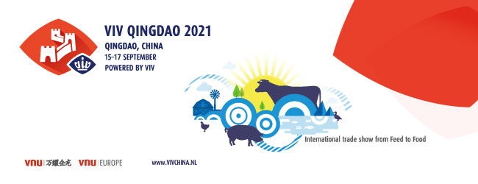
VIV QINGDAO 2021 Hosted Buyer Application Form
Dear Buyer,

If you work in a large-scale farm, feed mill or are a whole-industry chain operator and distributor, and you have clear purchasing needs and are the purchase decision maker or influencer in the next year, please be sure to fill out the following application form with accurate information and answer the questionnaire, then revert to us at klaus.yuan@vnuexhibitions.com.cn or call +86 21-6195 3505 for application before September 3, 2021.

As a hosted buyer of VIV QINGDAO, you will enjoy the following exclusive benefits during the exhibition period (September 15-17):
* Free accommodation（5-star hotel up to 2 nights）
* Free buffet lunch (up to 2 days)
* Free access to the exclusive lounge with your badge
* Fast-track access to the exhibition site
* Free access to partial onsite conferences

Tips: As the epidemic prevention and control has become a normal practice of 2021 across the country, the exhibition will strictly follow the government's requirement of "real-name registration" for visit appointment of the exhibition. Please be sure to fill out the registration form accurately with your basic information and bring your ID card to the exhibition site for admission.

1. Basic Information
First Name |  | Last Name
Country |  | Passport No.
Company Name |  | Department
Job Title |  | Email
Mobile |  | Office Tel (Direct Line)
Company Website |  | Address

2. Questionnaire
- What’s your business nature?
☐ Agent / Distributor / Wholesaler / Retailer
☐ Farm
☐ Feed Mill
☐ Manufacturer

- In which range of products are you interested in purchasing :
☐ Feed and feed ingredients
☐ Feed additives
☐ Feed milling equipment
☐ Bio-products (Vaccine, Veterinary drugs and etc.)
☐ Veterinary equipment/ Disinfection & Protective equipment
☐ Veterinary drug production and packaging equipment
☐ Breeding/Hatching
☐ Breeding/Hatching equipment
☐ Housing design & construction
☐ Farming & Feeding equipment
☐ Environmental control equipment (Ventilation, Temperature and etc.)
☐ Lighting equipment
☐ Accessories/ Assorted & Processing equipment for farming equipment
☐ IT & Automation services
☐ Waste Treatment equipment & Bio-energy Technology
☐ Laboratory testing equipment and services
☐ Slaughtering & Meat/ Egg Processing & Handling
☐ Logistics/ Refrigeration/ Package
☐ Aquaculture Farming Technology & Equipment
☐ Ruminant Farming Technology & Equipment
☐ Others:

- Please provide the detailed information of the product which you are interested in purchasing in Q2:
 | Detailed description of the product you are interested in purchasing (within 100 words) | Purchasing Quantity | Purchasing Budget (USD) | To which specie is your company’s product mainly related?
Product  A |  |  |  | ☐ Swine  ☐ Poultry broilers  ☐ Poultry layers  ☐ Dairy cows  ☐ Cattle/Calves (meat)  ☐ Sheep/Goat  ☐ Fish/Shrimps/Aquatic  ☐ Waterfowl  ☐ Pets  ☐ Others
Product  B |  |  |  | ☐ Swine  ☐ Poultry broilers  ☐ Poultry layers  ☐ Dairy cows  ☐ Cattle/Calves (meat)  ☐ Sheep/Goat  ☐ Fish/Shrimps/Aquatic  ☐ Waterfowl  ☐ Pets  ☐ Others

- Please name three companies/brands you’d like to make contact with during this session?
A.
B.
C.

* Kind reminder: All hosted buyers need to guarantee a 2-day visit to the exhibition and match-making with at least 8 exhibitors onsite. We will review the information you submitted above. Upon passing our review, you will be contacted about the next steps.
_________________________________________________________________

To apply, please fulfill this form, duly completed, send back before September 3, 2021.
Contact person:

VNU Exhibitions Asia
Mr. Klaus Yuan
Email: klaus.yuan@vnuexhibitions.com.cn
Tel: +86 21-6195 3505
Mob: +86 13916156991
__________________________________________________________________
WWW.VIVCHINA.NL

